TOFTigers & PUG Logos Use: Terms and Conditions

The TOFTigers logos and those of the Pug Eco rating certification are the property of The TOFTigers Initiative Ltd UK, a wholly owned enterprise of the Nature Stewardship Alliance charity in UK (No 1172519), hereto referred to as TOFTigers.

The Logos (illustrated below) may only be used by TOFTigers members in good standing and accordance with the terms and conditions set forth below. Use of one or more of the logos shall constitute consideration for, agreement to, and acceptance of the following terms and conditions of this license by the user:

1. The TOFTigers and PUG logos are the sole and exclusive property of TOFTigers. These logos may be used only by current and fully paid up TOFTigers Tour Operator, travel agent members or DMC member or other TOFTigers representative members in good standing if and only if such use is made pursuant to the terms and conditions of this limited and revocable license. Any failure by a user to comply with the terms and conditions contained herein may result in the immediate revocation of this license, in addition to any other sanctions imposed by TOFTigers. The interpretation and enforcement (or lack thereof) of these terms and conditions, and compliance therewith, shall be made by TOFTigers at its sole discretion.
2. The use of PUG logos reflects your existing agreement as a member of TOFTigers that namely, you have agreed to promote and use PUG eco-rated accommodation wherever possible, or if you are not using a TOFTigers eco-rated accommodation provider, encourage them to register and undertake the PUG certification process.
3. The logos may not be revised or altered in any way, and must be displayed in the same form and colour as produced by TOFTigers. The PUG logos can be used on the proviso that their use is not misleading the public as to what is or isn’t certified. TOFTigers reserves the right to request changes should TOFTigers deem it necessary.
4. The logos may be used in a professional manner on the user's business cards, stationery, literature, websites, itineraries, social media, advertisements, store-front window, or in any other comparable manner to signify the user's membership with TOFTigers and/or commitment to PUG. Notwithstanding the foregoing, the logos may not be used in any manner that, in the sole discretion of TOFTigers: discredits TOFTigers or tarnishes its reputation and goodwill; is false or misleading; violates the rights of others; violates any law, regulation or other public policy; mischaracterizes the relationship between TOFTigers and the user, including but not limited to any use of the logos that might be reasonably construed as an endorsement, approval, sponsorship, or certification by TOFTigers of the user, the user's business or organization, or the user's products or services, or that might be reasonably construed as support or encouragement to purchase or utilize the user's products or services.
5. Use of the logos shall create no rights for users in or to the logos or their use beyond the terms and conditions of this limited and revocable license. The logos shall remain at all times the sole and exclusive intellectual property of TOFTigers. TOFTigers shall have the right, from time to time, to request samples of use of the logos from which it may determine compliance with these terms and conditions. Without further notice, TOFTigers reserves the right to prohibit use of the logos if it determines, in its sole discretion, that a user's logo usage, whether wilful or negligent, is not in strict accordance with the terms and conditions of this license, otherwise could discredit TOFTigers or tarnish its reputation and goodwill, or the user is not a TOFTigers member in good standing.
6. Any questions concerning use of the logos or the terms and conditions of this license should be directed to TOFTigers : admin@toftindia.org

LOGOS FOR USE BY MEMBERS CAN BE EXTRACTED FROM HERE OR JPEGS SENT BY EMAIL. Contact admin@toftindia.org

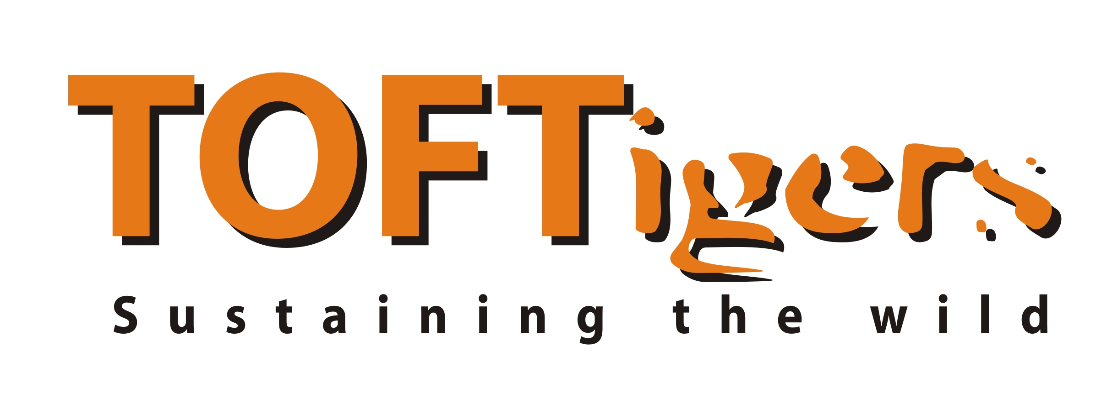 | TOFTigers corporate logo for use by existing TOFTigers members (eg on your responsible travel or charity partnership pages).  Hyperlink to www.toftigers.org
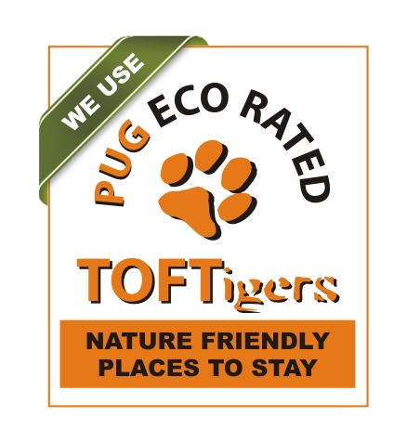 | Singular PUG Logo Option 1  For use by existing TOFTigers members to indicate they use PUG eco-rated places to stay. This logo can be used as an alternative or in addition to the corporate logo above.
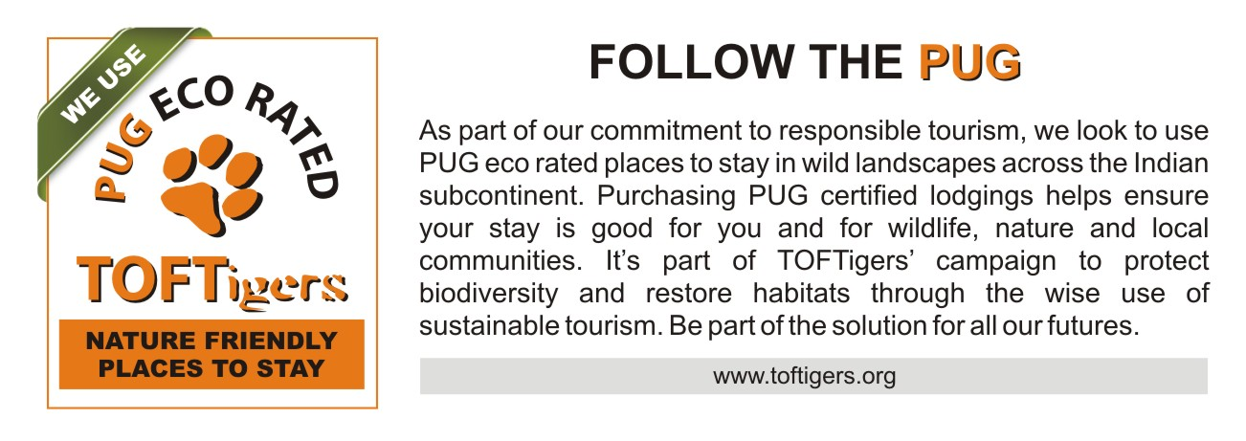 | Composite PUG Logo with explanation Option 2  For use by existing TOFTigers members to indicate they use PUG eco-rated places to stay. This logo can be used as an alternative or in addition to the corporate logo above.  Hyperlinked version here:  
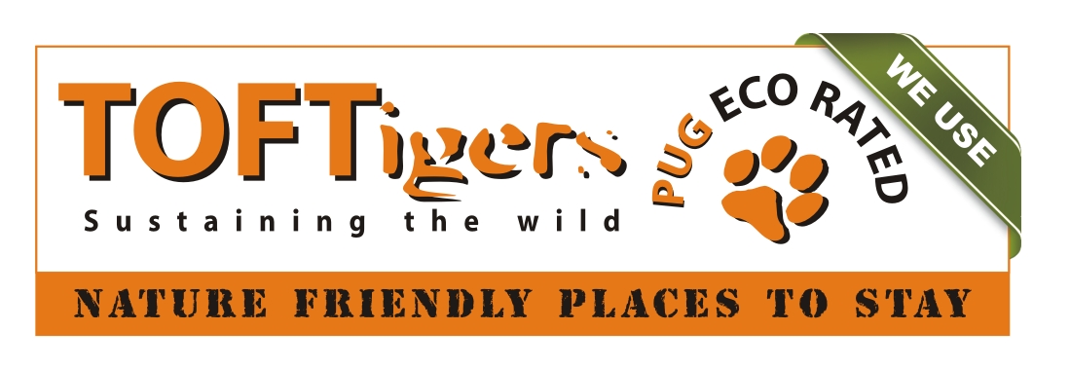 | Singular PUG Logo Alternative Option 2  For use by existing TOFTigers members to indicate they use PUG eco-rated places to stay. This logo can be used as an alternative or in addition to the corporate logo above.
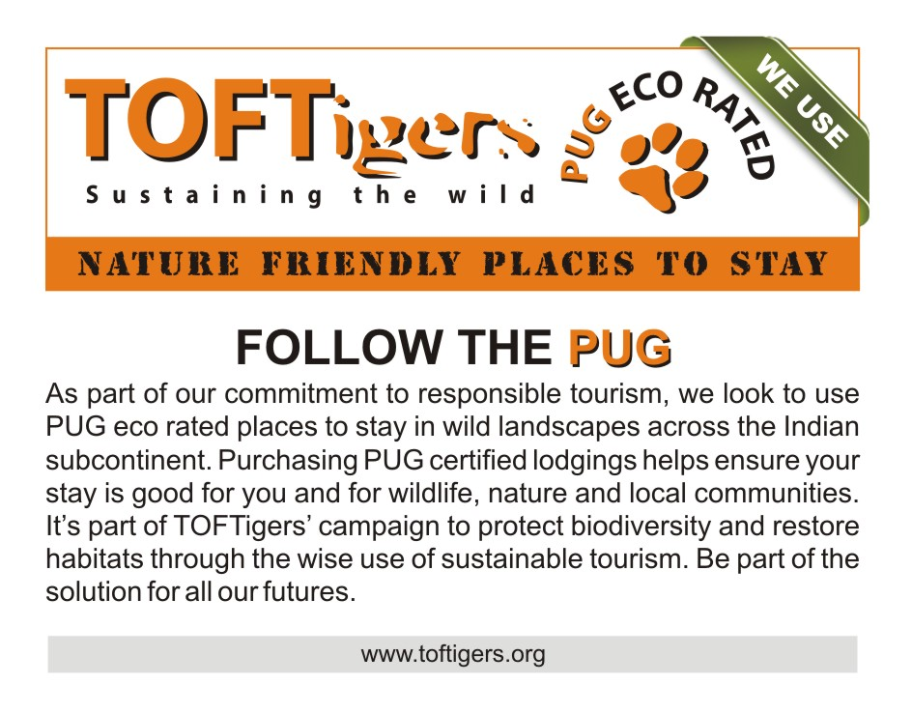 | Composite PUG Logo Alternative with explanation Option 2  For use by existing TOFTigers members to indicate they use PUG eco-rated places to stay. This logo can be used as an alternative or in addition to the corporate logo above.  Hyperlinked version here:  

